Gun Range + Wine Tasting (Constantia/Stellenbosch)
A premium adult‑only experience.
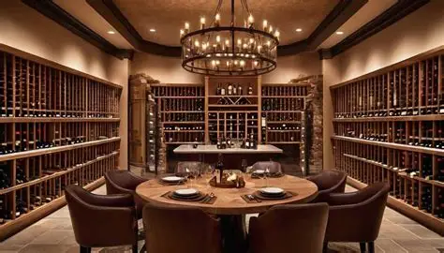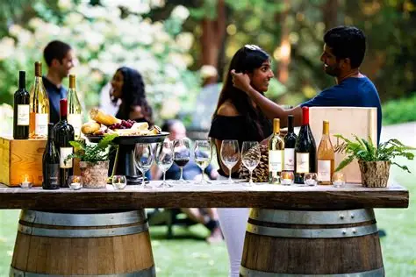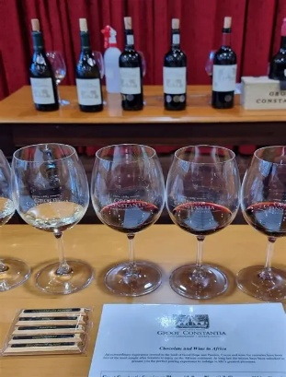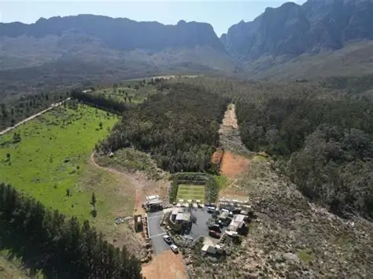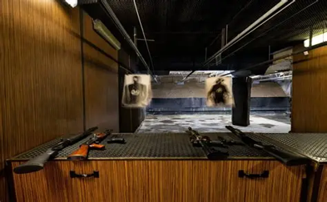
Tour Overview
Enjoy a shooting session followed by wine tasting at two top estates in Constantia or Stellenbosch.
Itinerary
- Shooting range session
- Visit 2 wine estates
- Optional cheese pairing
Inclusions
- Private transport
- Shooting range session
- Wine tasting fees (optional add‑on)
Exclusions
Lunch
Price
2–4 guests: R7,680 total and 5–7 guests: R10,600 total

